**Заметки по проекту:**

Согласно [презентации](https://docs.google.com/presentation/d/1-_PaviD4evoR5dhEcSWwJXvYEpBAzfl9/edit#slide=id.p5) **задача проекта звучит так:**

NUST MISIS is taking part in a project, whose goal is to maximize the competitive position of leading Russian universities in the global research and educational market among technical universities worldwide. You have been selected to present NUST MISIS at an educational conference. Find evidence for and evaluate our university’s chances of entering the final stage competition.

*Можно сузить презентацию до какой-то отдельной сферы.

**Этапы проекта:**

1. Генерация идей, формирование группы, выбор темы
2. Сбор данных и исследование темы
3. Создание презентации
4. Написание Review?

**Финал проекта:**

3х минутная презентация в классе. Оценивается:

1. Подготовленность
2. Визуал
3. Грамматика
4. Произношение
5. Контент

**Идеи:**

Перечислить партнеров ВУЗа.

Рейтинг ВУЗа по какому?

Исследования проводимые в ВУЗе.

**НАД ЧЕМ РАБОТАЕМ:**

**Нужно подготовить текст на Английском**

Глеб - партнёры МИСИС, трудоустройство студентов с 3его курса

Нека - преимущества работы и разработки в МИСИСе как сотрудник

Катя - место МИСИСа в рейтинге вузов + Преза

Катя:

Established in 1918, NUST MISIS is a leading Russian university focused on metallurgy, materials science, and mining. Over the years, it has expanded its expertise to include nanotechnology, IT, and bioengineering.

This presentation highlights the university’s current rankings, development strategies, and key industry partners.

Nowadays MISIS takes the 12th place among universities of Moscow and the 25th place in the rank of all Russian universities. The closest universities to MISIS in the rating are Moscow University of Aviation and Moscow Energetical University. As you see, there is a big rivalry between Russian technical universities so in our presentation we would like to highlight the main advantages of studying and working in NUST MISIS

MISIS is known not only for its education but for scientific discoveries. Here are some reasons to apply to MISIS as a student and as a worker

Глеб:

**MISIS industrial partners and employment assistance**

1. **MISIS industrial partners**

Industrial partners of MISIS university are companies that collaborate closely with the university and often hire its graduates for their projects.

Among MISIS partners there are many famous companies such as:

BearingPoint - business consulting company

1C - software developing company

Loginom - IT company which created “Loginom analytical tool”

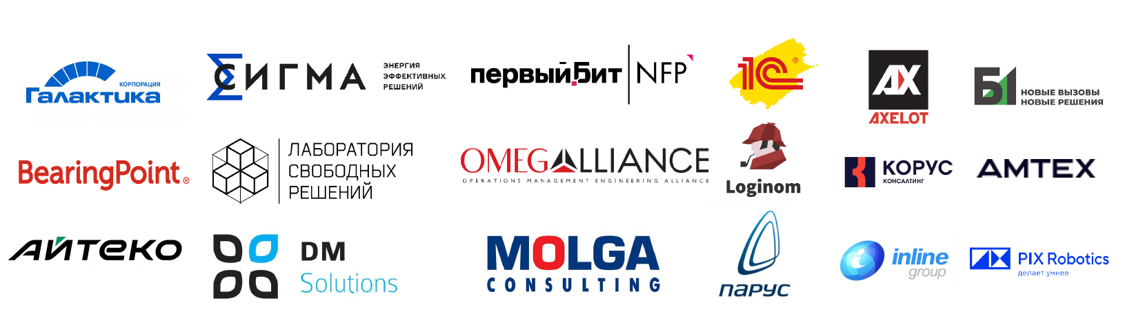

1. **How to get hired at MISIS?**

In order to get hired MISIS student should:

* study well and pass all exams successfully
* Visit “Introduction to specialty course”, because companies visit us here and announce internship and job opportunities.

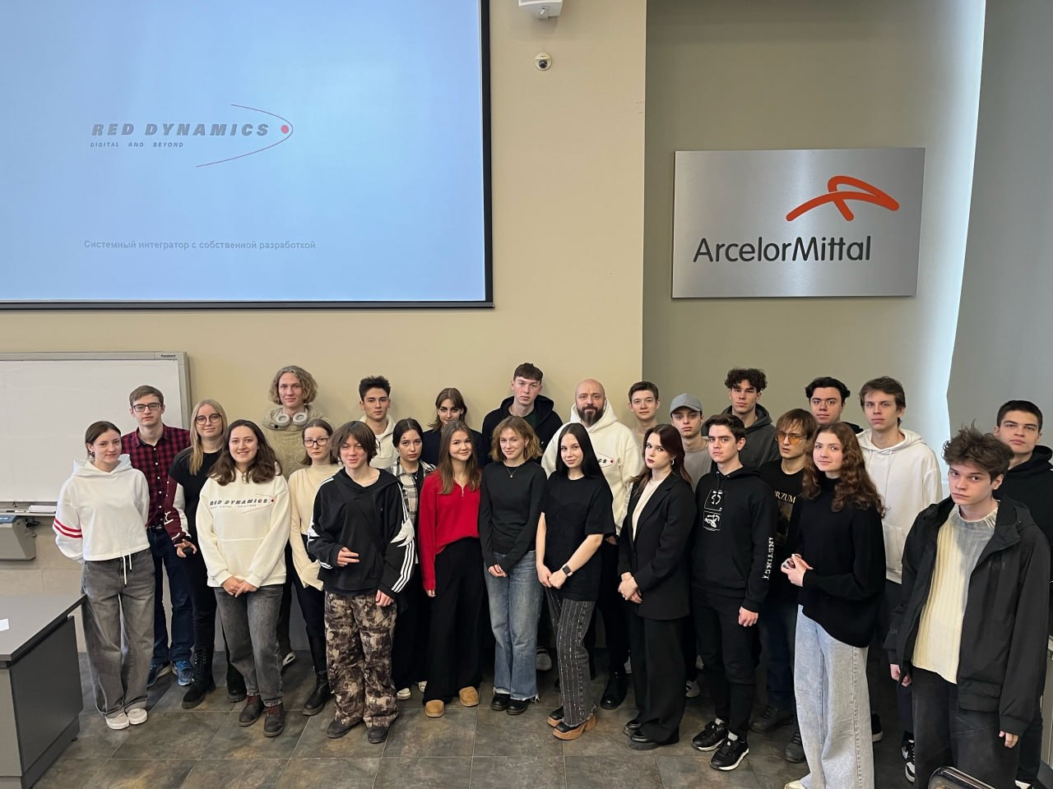

For instance, in the previous week we had a meeting with the Red Dynamics company.

1. **Student employment statistics**

According to MISIS student employment statistics in 2024:

62% of students are hired and work in companies

12% are currently on an internship in companies

7% are self-employed

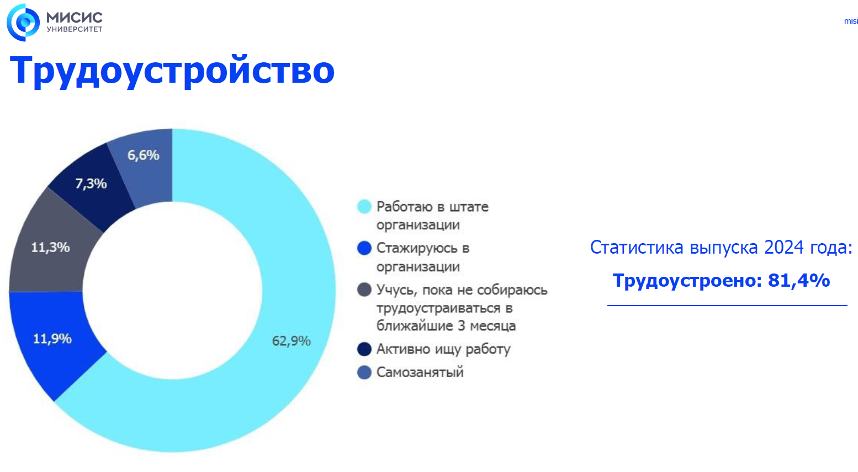

1. **Success cases**

To conclude the employment assistance of MISIS University I want to mention some success cases:

* Our dear mentor Karina Elesina - head business analyst.
* Ulyana Valerievna - Analyst-developer at Elma365
* Ilya Olegovich - Project Manager

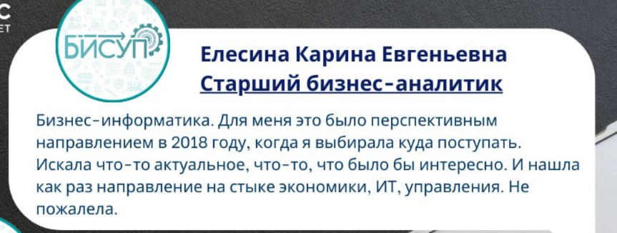

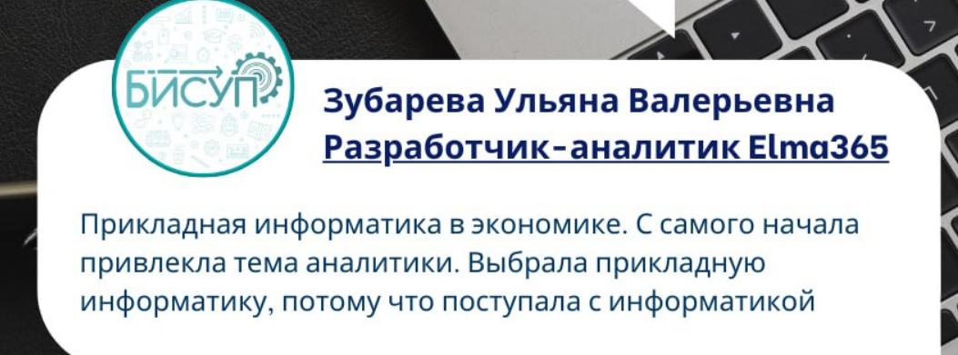

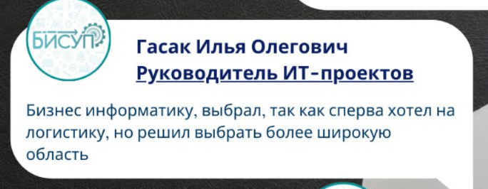

Нека:

**Advantages of Working at MISIS as a Researcher**

**1. Professional Opportunities**

* **International Collaboration**: Participation in international grants and joint projects with top universities worldwide.
* **Innovative Equipment**: Access to advanced laboratories equipped with analytical instruments, microscopes (SEM, TEM), 3D printers, spectrometers, and high-performance computing clusters.
* **Grant Support**: Internal funding programs and assistance with applications for national and international grants.

**2. Financial Benefits**

* **Salary**:
  + Young researchers and PhD students(аспиранты): RUB 60,000 to 100,000 per month.
  + Experienced researchers: RUB 100,000 to 200,000, with potential increases through grants.
  + Leading scientists: RUB 200,000 and above when participating in major projects.
* **Additional Benefits**: Funding for travel, conference participation, and bonuses for publications in high-impact journals.

**3. Career Development**

* Special programs for young scientists, with mentorship opportunities.
* Possibilities to commercialize research through the technopark and startups.

**4. Social Support**

* Health insurance, housing, and transport compensation.
* Flexible schedules and a comfortable working environment.